**Sensors and actuators based on Flemion: advantages and limitations**

Minoru Taya* and Jin Wang**,

*Center for Intelligent Materials and Systems, University of Washington

** currently at imergypower, San Francisco

Abstract:

The key ionic polymer membranes are Nafion made by DuPont and Flemion by Asahi Glass Company. Flemion has been studied as an IPMC mainly by Oguro’s group in Japan, which has achieved excellent results in Flemion-based IPMC actuation amplitude [1]. The major difference in the actuation between Flemion and Nafion is the back relaxation, namely the deformation is stable or even increases as long as the voltage is applied quasi-statically. We designed both actuator[3] based on Flemion where we used four types of ionic ;1-Butyl-3-methylimidazolium tetrafluoroborate (BMI-BF4),1-Butyl-3-methylimidazolium, hexafluorophosphate (BMI-PF6), 1-Ethyl-3-methylimidazaolium trifluoromethanesulfonage (EMI-Tf), and 1-Ethyl-3-methylimidazaolium bis(trifluoromethylsulfonyl) imidate (EMI-Im). Fig. 1 shows some of the experimental data of the displacements induced by applying low frequency applied voltage of 3V.



Fig. 1 Curvature response of Flemion-based IPMC in cantilever configuration under 3V with frequency of 0.025Hz where four different ionic liquids are used, BMI-BF4(bold line), BMI-PF6(dash line with triangle marker), EMI-Tf (dash line with dot)and EMI-Im(dash line with inverse triangle) [2]

Force is also measured for the cantilever of Flemion beam with BMI-BF4 and the results are plotted in 

Fig. 2. Force response of Flemion-based IPMC with BMI-BF4 in cantilever configuration under 5V with 0.025Hz [2]

We also designed bioinspired tactile sensor based on Flemion, where dome-shaped tactile papillae on the surface of a cucumber tendril is used for designing arrayed Flemion, each dome is cut with laser beam into four segments so as to use them as tactile sensing for unknown 3D vectorial force.

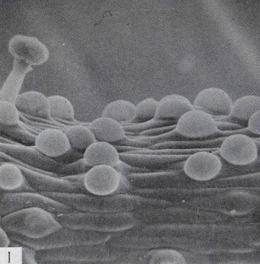 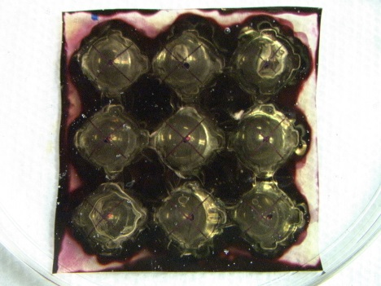

Fig. 3 Bioinspired tactile sensor based on Flemion, (a) cucumber tendril with dome-shaped tactile sensor cells, (b) arrayed Flemion tactile sensor system and (c) typical sensor signals under applied horizontal force applied at west foot hill [3].

It may be concluded from our recent results that Flemion has limited blocking force capability, while use of Flemion as tactile sensor to detect 3D vectorial force is advantageous over other types of sensor design.

References

[1] Fujiwara N, Asaka K, Nishimura Y, Oguro, K. and Torikai E., 2000, “ Preparation of gold–solid polymer electrolyte composites as electric stimuli-responsive materials”, *Chem.Mater.* **12** 1750–4.

[2] Wang, J., Xu, C., Taya, M. and Kuga, Y., 2007, “A Flemion-based actuator with ionic liquid

as solvent”, *Smart Mater. Struct*. **16** , S214–S219.

[3] Wang, J. Sato, H., Xu, C. and Taya, M., 2009, “Bioinspired design of tactile sensors based on Flemion”, *J. Applied Phys*., 105, 083515.